Keeping Active With A SMILE
By Jenna Benson
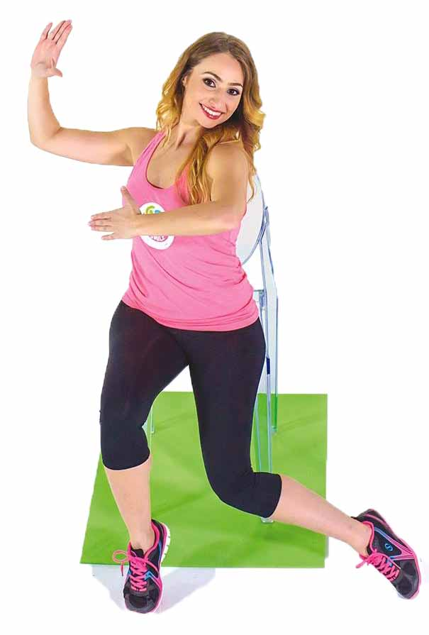
When former Australian Junior Ballroom and Latin Dance Champion Gina Buber noticed the dwindling number of older adults turning up at her weekly dance classes, she knew something was wrong.

“I had been teaching seniors for a number of years and found that as time went by, more and more students found that my existing fitness classes were too fast for them. Consequently, they stopped coming to class and ceased doing any physical activity.”

As a result, the 29-year-old decided to create a similar class for the wider adult community – particularly those who found standing exercise classes too difficult – to encourage them to become active again.

“I wanted to develop a program that made exercise fun, low impact and available for all no matter their physical ability. As a result, the SMILE Program was born.”

SMILE stands for Social Movement Improves Life Everyday; a low-impact, chair-based workout program for the older adult and those with limited mobility, based on ballroom and Latin music and moves.

After witnessing the success and demand for the program, Buber decided to create a range of DVDs, to make the program available to people all around the world.

“I believe there should be nothing stopping you from doing daily exercise. This is why I created the DVD. It encourages people to workout as often as they like and at any time they desire.”

Given Buber’s professional background in ballroom dance over the past 20 years, the sounds and rhythms of the Foxtrot, Cha Cha Cha and Tango are at the heart of the program.
And, her students sure do love it!

“A participant said that coming to class made her heart smile. She doesn't get out much and said she needs this class to have something to look forward to every week. She said if it weren’t for the class, she would most likely be in a nursing home!”

Gina Buber’s new DVD, SMILE & Sway, is available to purchase online at www.spreadthesmile.com.au.

